Literacy
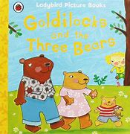
Read or listen to……

Goldilocks and the 3 bears
https://www.youtube.com/watch?v=AOXqZw9kj-I&feature=youtu.be
and
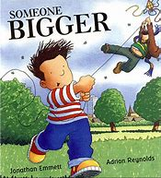
Someone bigger

https://www.youtube.com/watch?v=dPYn2UGTHfY&feature=youtu.be

Creative Ideas
Goldilocks eats porridge in the story, have a try at making flapjacks from porridge oats
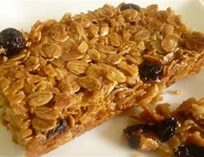
Additional extra ingredients
100g any dried fruit

Ingredients
85g butter
90g brown sugar
55g golden syrup
100g rolled oats
30g rice krispies
¼ tsb salt

Sam in the ‘Someone Bigger’ story flies a kite, have a try at making a kite

Physical Development
If you have a kite take it to the park to fly it you may need to try running, looking at where your kite is and
being careful of what is happening around you.
Help tidy your bedroom and maybe learn a new skill like folding your clothes and tidying them away.

Letters and sounds
Try the phonics play games
https://www.phonicsplay.co.uk/resources/phase/1/welcome-to-the-zoo

Maths
In the ‘Someone Bigger’ story Sam is the smallest in his family, who is smallest person in your family and
who is the biggest, if you have lots of people in your family can you put them in order of tallest to smallest.
In the Goldilocks and the Three Bears Story there are big, medium and small things, can you find three
things in your home that are the same but are big, medium and small sizes.
Have are try at the ‘Let’s Compare’ Game
https://www.topmarks.co.uk/early-years/lets-compare

